Crm Main Bar
3 horizontal dots
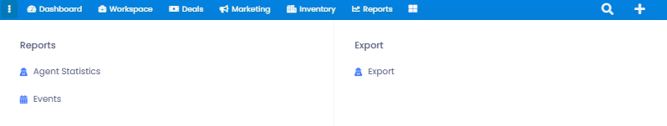
when clicked on shows
Reports Export
Agent statistics Where we can upload data from crm so we
Events can print it
Reports will be shown Detailed in reports page
Exports
Export Request - Filter
if we wanna know who did the action , when or what source , intrest ,etc....
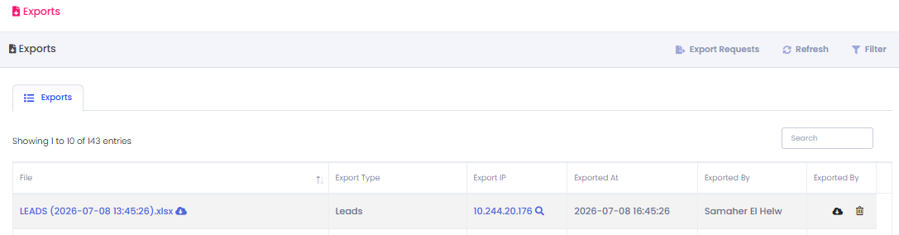
File name export type Export IP Date By who icons to
Type Of Ledas upload or delete

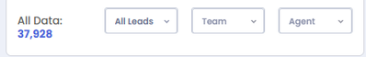
--- Dashboard Selection ------ All Leads Where we can select ( Warm – Cold -All leads) - Team ( For Team Selection) - Agent (For Agent selection)
then all the stages under each other
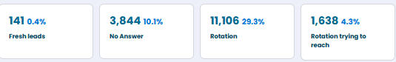
At the bottom we find Recent Activity Calls
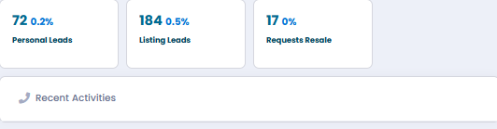
when clicked on it
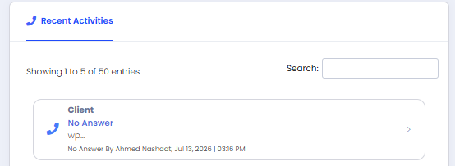
we find the leads + the Call Action + feedback + Search Bar
then Agent + Date & Time
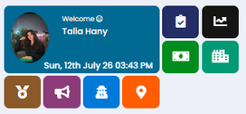
1 - Profile ( Date – Picture – Title )
top Agents
Plus the icon
title
points
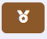
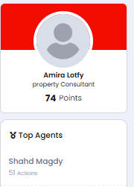 | 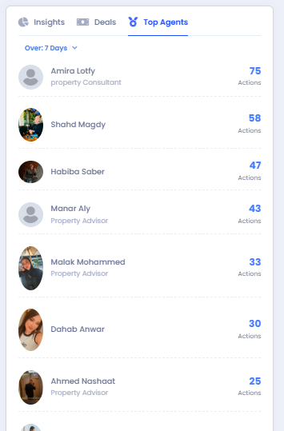

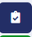

2- Todo’swhen clicked on – Follow up (Action) – (Schedule Meeting)
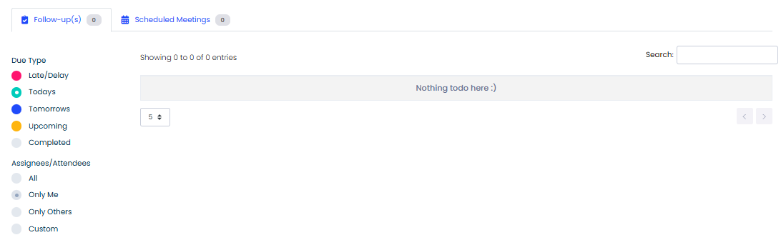
-Due type ( where u can choose the date of Late or delay – todays – tomorrows – upcoming and completed -follow ups Assignes \ Attendees all – all agents only me ( user) only other ( all except user )
- custoum ( where I can select agent
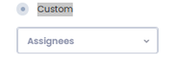
Search – where I can search for a lead name – number – agent
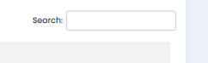

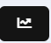 | 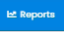
3-Reports Icons
Directs you to
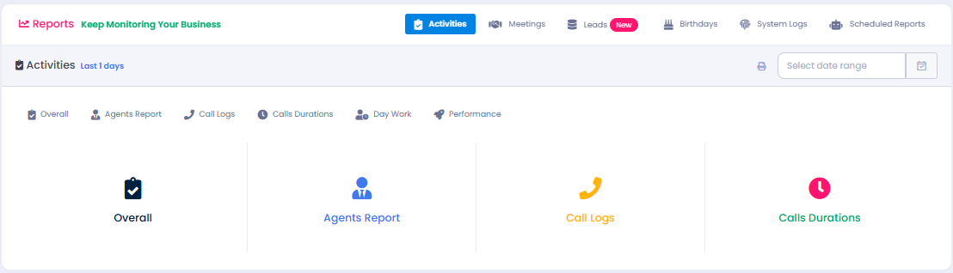
1- Overall
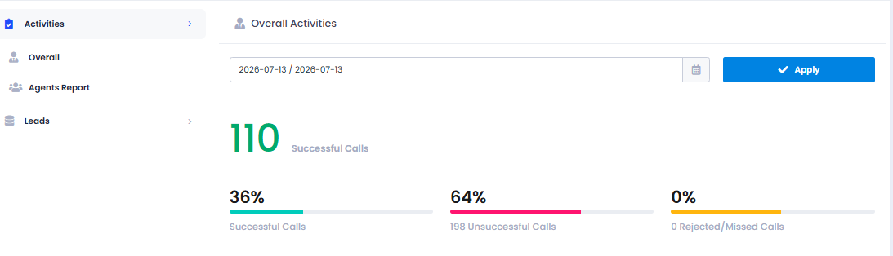

where i can select day date or Date Range
and it shows bunch of statistics ( Calls - meeting -Taska - Messages ,etc)
2- Agent Report
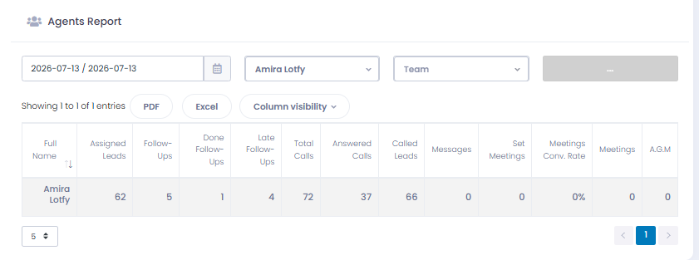
where i can select Date or Date range + Agent
will bring all his activites on crm
3- Call Logs
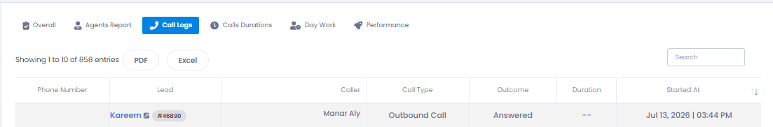
All cal logs on crm
4-Call Durartion
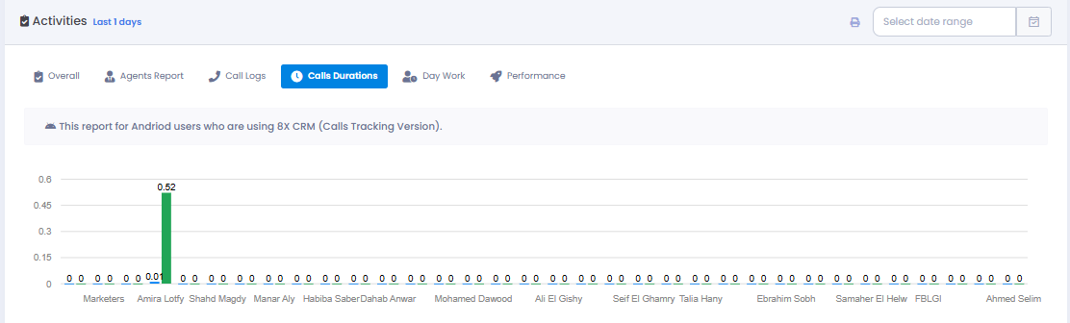
with a Date Range bar
all crm users
+ Duration of a call
5-Day Work
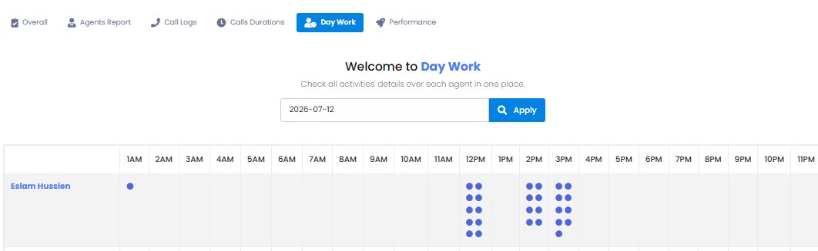
Date range + All agents with a time for actions
which let us know the peak hour for every agents’s work
6-Performance
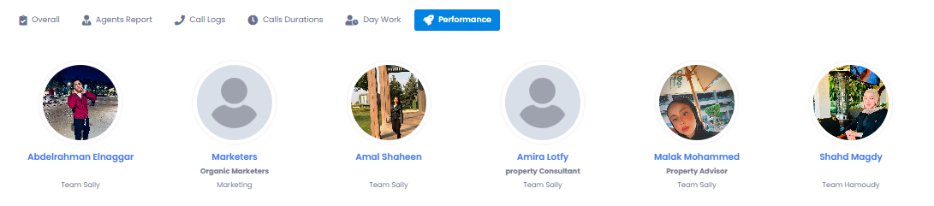
we can select time range then if we clicked on any agent
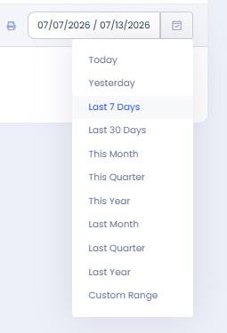
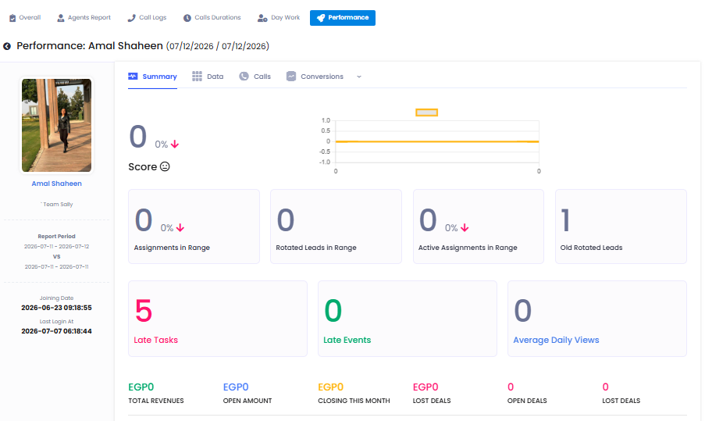
we can find another way for a performance report with a bunch of statistics
2-meetings
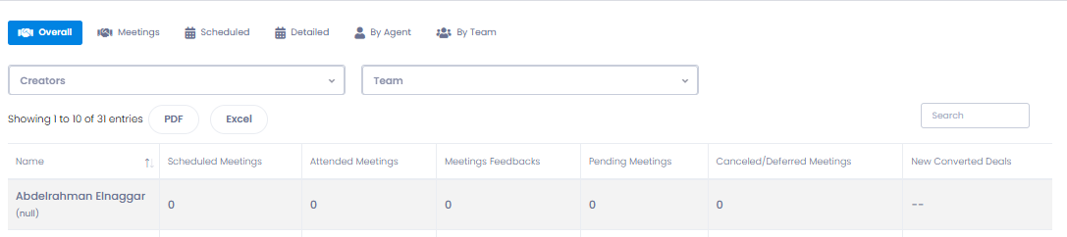
Creator + Agent Selection
3-Leads Report
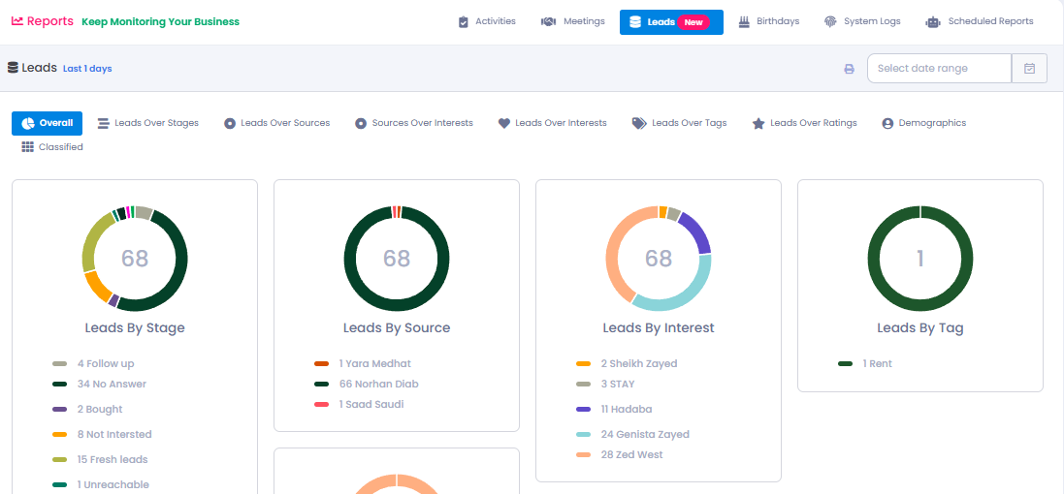
we can find an overall statistics report
leads over stage
leads over source
source over intrest
leads over intrest
+ a date range bar
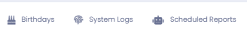
as for these we dont use them much actually
3- Deals Icons
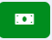

it will direct you to
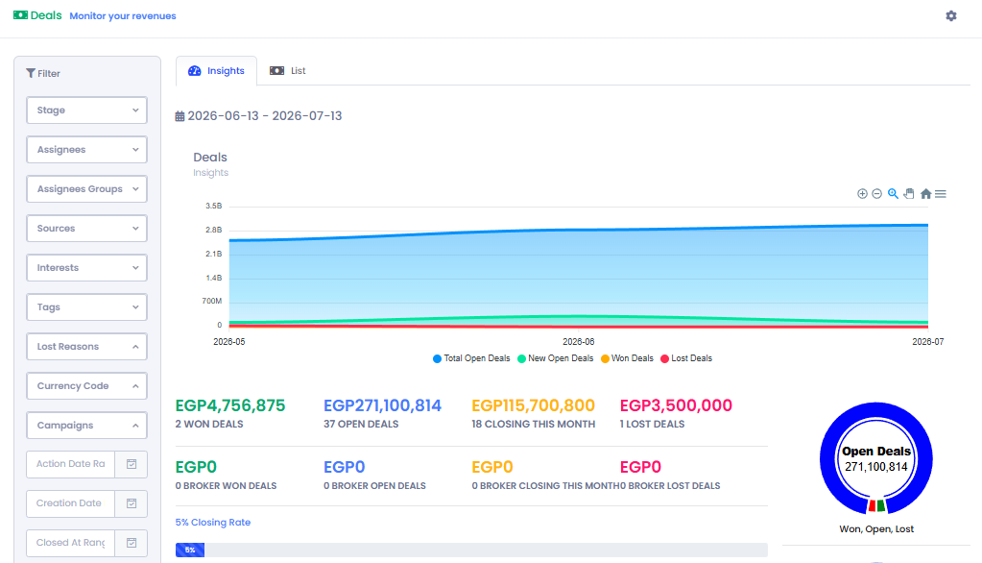
insights for our deals
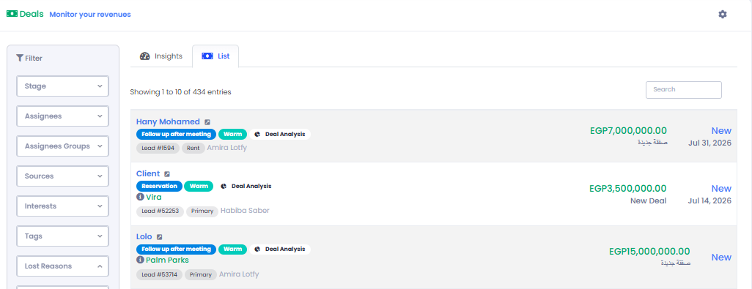
lists for every new deal Action Made by agent and Its lead
Filters where it helps us into reports or searching for a lead or analysis
4- INVENTORY


these two icons will direct us to our inventory
5 - Markrting
 | 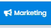
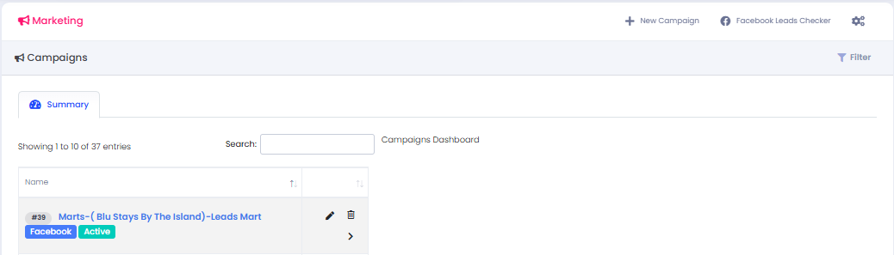
we will find all acampaigns
Search Bar
Filters
+ New Campaign “
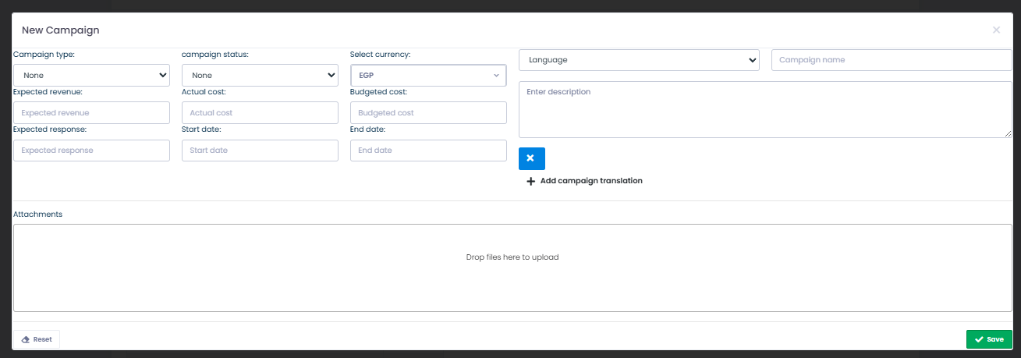
6- check ins& Out


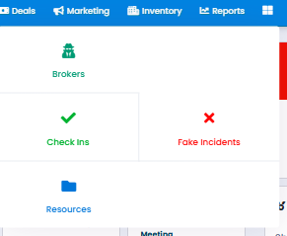
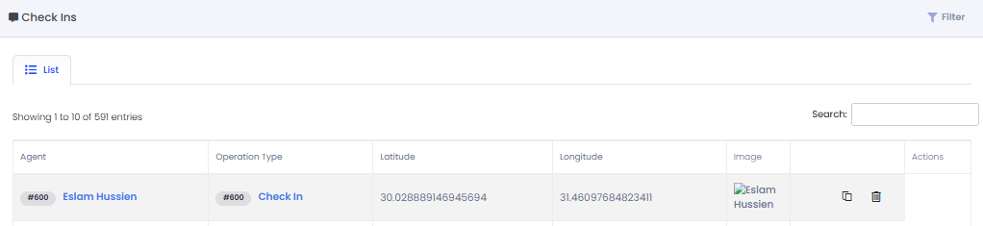
we can find all checkn’s & out’s on every lead
if we Clicked on check in we will find
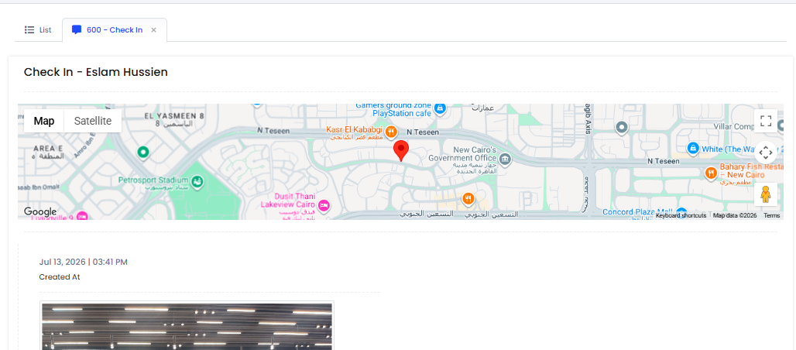
location
date & time
agent
picture
Workspace
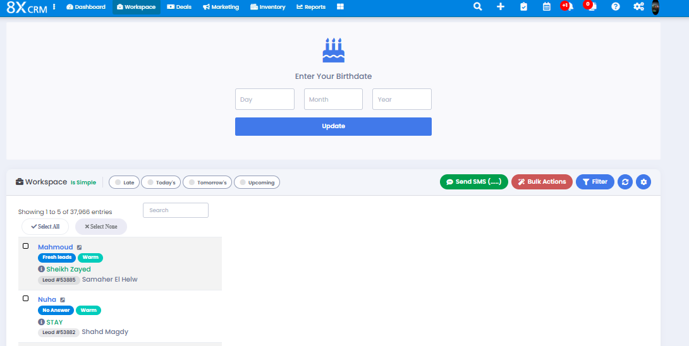
First we have an easy access to
( Late - Todays- Tomorrows- Upcoming)
example on late actions
here we can select all or none
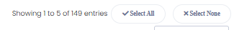
here we can select a value
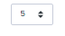

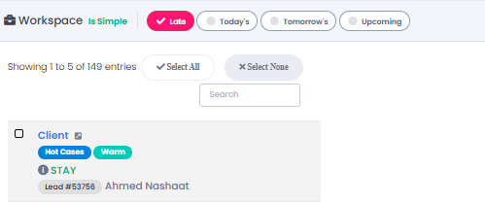
we have almost 150 late actions
and so one with the rest
on the other side
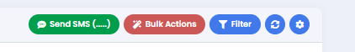
1- sms
we can select a bunch of leads so send sms
2-Bulk Actions
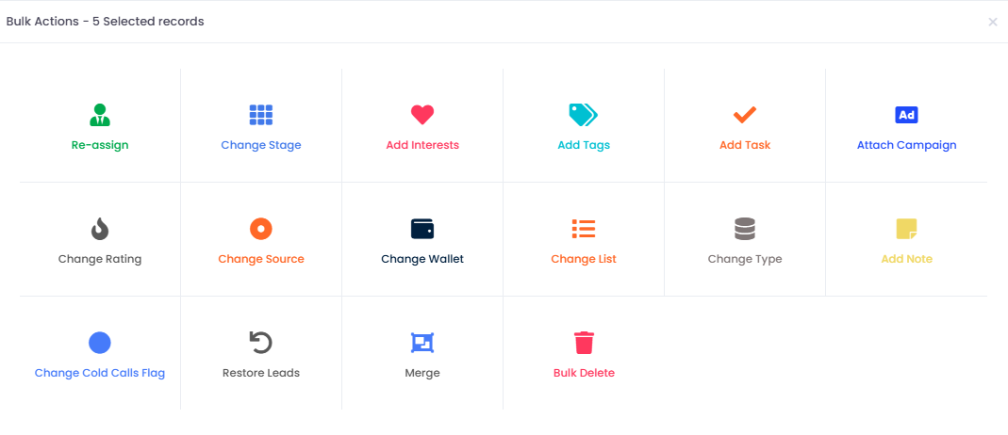
a lot of actions where we can select a number of leads to make one actions once and for a quantity of leads
3- Filters
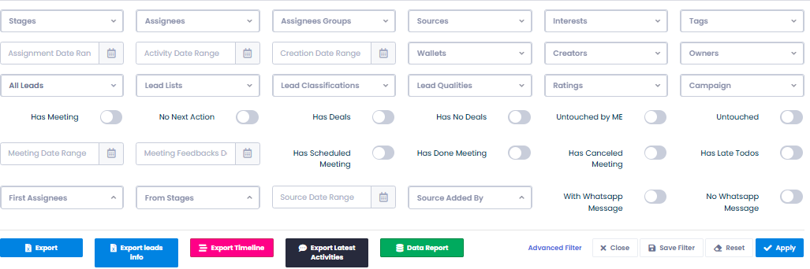
helps us with analysis and reports
the export bar
1 export leads
2 leads Info
3 timeline
4 Data Report
shows all stages for a selected filters in simple way
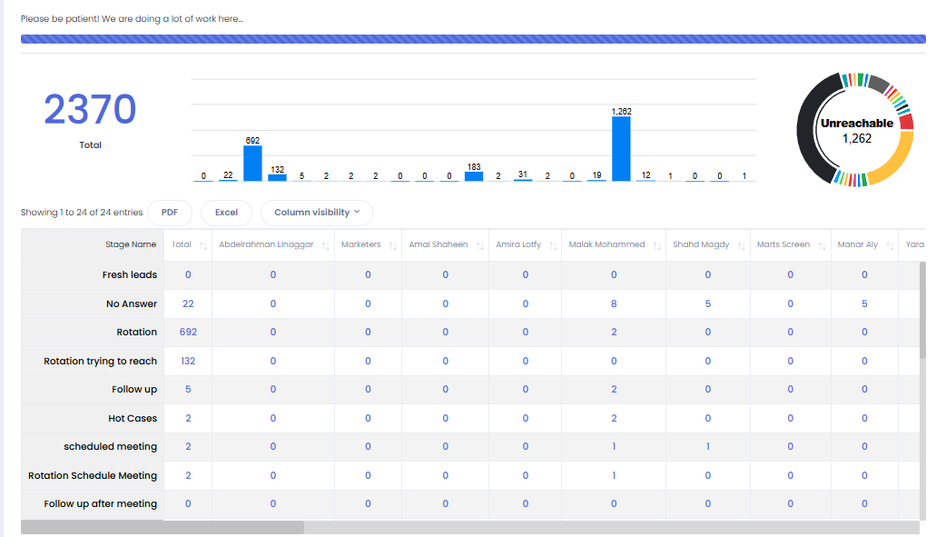

1 Search Bar
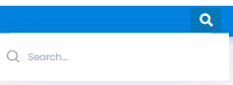
2- Plus Sign
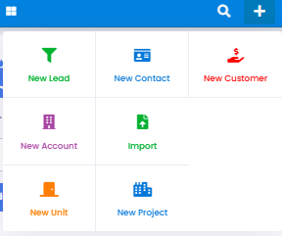
we only use
1 new lead
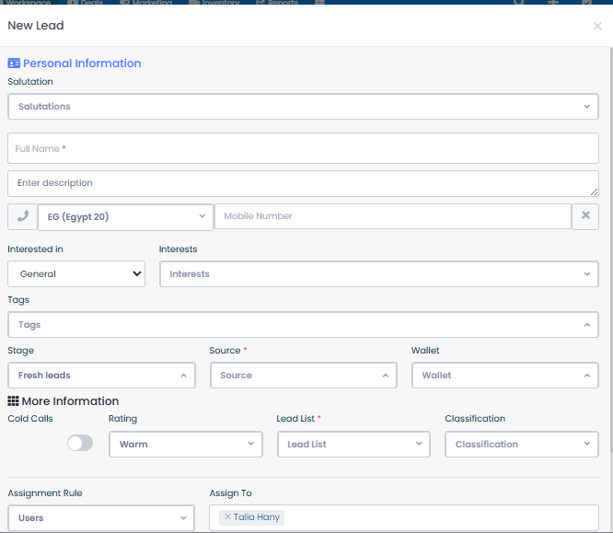
2 Import For bulk Leads
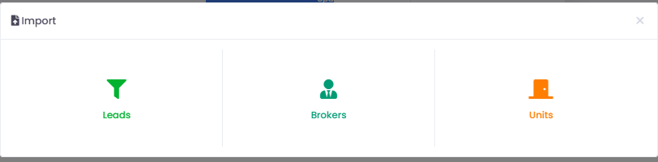
then we select Leads
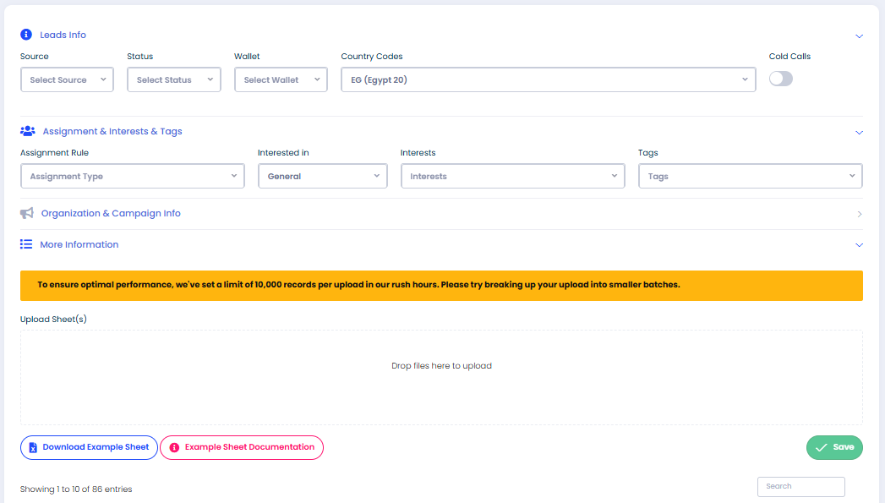
3 New Unit
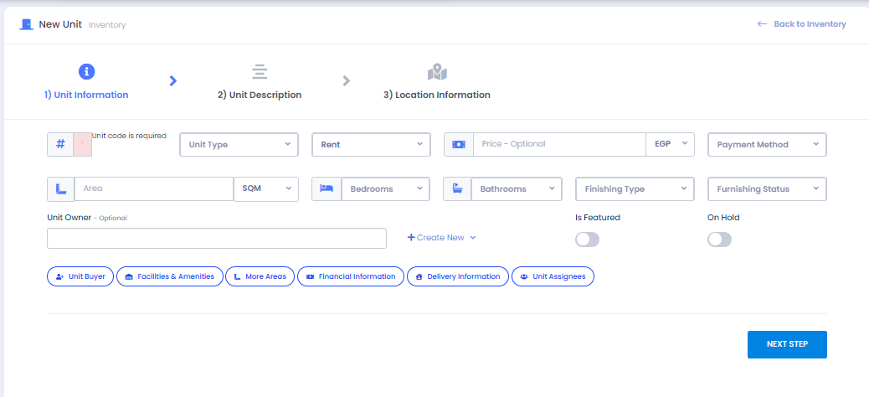
Notifications
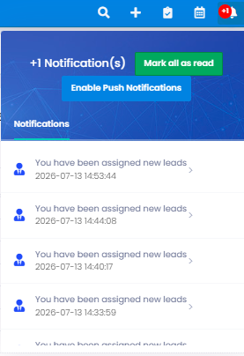
- Dublication
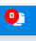
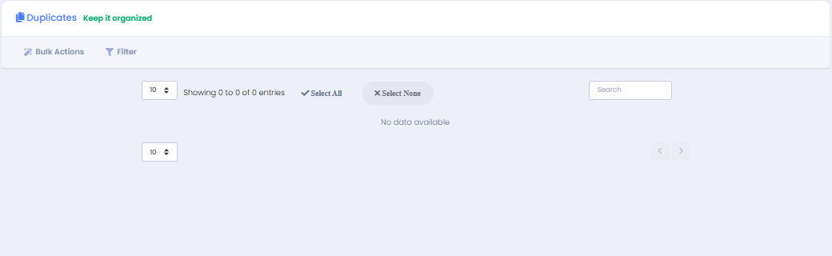

CRM Settings + Profile

